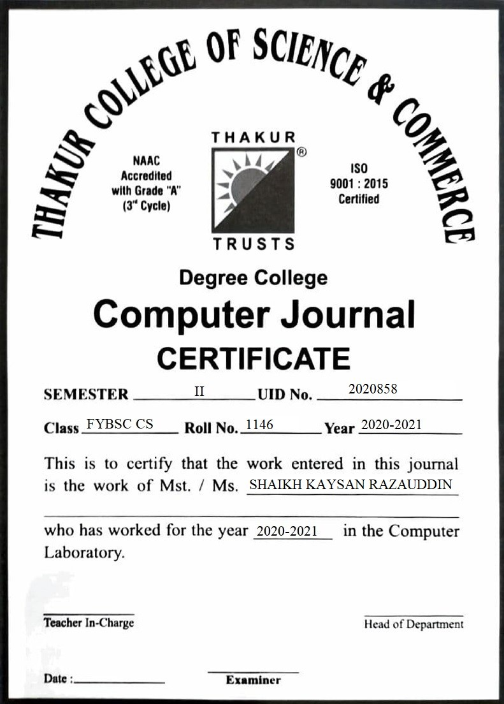

INDEX

|  |  |  |
| --- | --- | --- |
| SR  NO | Practical’s | Page No |
| 1 | Generating Iterables | 3 |
| 2 | File Method | 8 |
| 3 | Iterators and Iterable | 12 |
| 4 | Errors and Exception | 14 |
| 5 | Regular Expressions | 22 |
| 6 | GUI (Using Tkinter Library) | 32 |
| 7 | Using Html in Python | 48 |
| 8 | Canvas | 55 |
| 9 | Database Connectivity | 71 |

|  |  |  |
| --- | --- | --- |
| SR  NO | Assignments | Page No |
| 1 | Using Assert, Finding roll numbers and Names | 20 |
| 2 | Application form (using tkinter) | 52 |
| 3 | Create a Simple Calculator using Tkinter | 65 |
| 4 | Window Traverse | 74 |

PRACTICAL -1

*GENERATING ITERABLES*

**#how to convert str into iterable**

>>> str="I am kaysan"

>>> iter_str=iter(str)

>>> print(str)

I am kaysan

>>> print(iter_str)

<str_iterator object at 0x000001FFC9520C40>

>>> print(next(iter_str))

I

>>> print(next(iter_str))

a

>>> print(next(iter_str))

m

>>> #generating iterable from dictionary

>>> student_details={'Kaysan':1111,'Ajay':2222}

**# Convert dictionary(iterable) into iterator object using iter()method.**

>>>iter_object=iter(student_details)>>> print(iter_object)

<dict_keyiterator object at 0x000002D69EF93060>

>>> print(next(iter_object))

Kaysan

>>> print(next(iter_object))

Ajay

>>> value_ele=iter(student_details.values())

>>> item_ele=iter(student_details.items())

>>> print(next(value_ele))

1111

>>> print(next(value_ele))

2222

**#generating iterable from list**

>>> list_1=["orange","apple","mango","banana","strawberry"]

>>> iter_list=iter(list_1)

>>> print(iter_list)

<list_iterator object at 0x000001FFC3520C40>

>>> print(next(iter_list))

orange

>>> print(next(iter_list))

apple

>>> print(next(iter_list))

mango

>>> print(next(iter_list))

banana

>>> print(next(iter_list))

strawberry

**#generating iterables from tuple**

>>> tuple_1=("red","green","blue","yellow","pink")

>>> iter_tuple=iter(tuple_1)

>>> print(iter_tuple)

<tuple_iterator object at 0x000001FFC9520C40>

>>> print(next(iter_tuple))

red

>>> print(next(iter_tuple))

green

>>> print(next(iter_tuple))

blue

>>> print(next(iter_tuple))

yellow

>>> print(next(iter_tuple))

pink

**#generating iterables from set**

>>> set_1={"dog","cat","rabbit","eagle","snake"}

>>> iter_set=iter(set_1)

>>> print(iter_set)

<set_iterator object at 0x0000021F941B1E80>

>>> print(next(iter_set))

dog

>>> print(next(iter_set))

cat

>>> print(next(iter_set))

rabbit

>>> print(next(iter_set))

eagle

>>> print(next(iter_set))

snake

**# generating iterables from range**

>>> x=range(8)

>>> for i in x:

print(i)

0

1

2

3

4

5

6

7

>>> iter_range=iter(x)

>>> print(iter_range)

<range_iterator object at 0x0000021F98271C70>

>>> print(next(iter_range))

0

>>> print(next(iter_range))

1

>>> print(next(iter_range))

2

>>> print(next(iter_range))

3

>>> print(next(iter_range))

4

>>> print(next(iter_range))

5

>>> print(next(iter_range))

6

>>> print(next(iter_range))

7

PRACTICAL -2

*FILE METHODS*

>>> fileobj=open("kaysan.txt","w")

>>> fileobj.write(We are learning GUI concepts in python programming")

SyntaxError: invalid syntax

>>>

>>> fileobj=open("kaysan.txt","w")

>>> fileobj.write("We are learning GUI concepts in python programming")

50

>>> fileobj.close()

>>>

>>> fileobj=open("kaysan.txt","r")

>>> readstr=fileobj.read(20)

>>> print("The contents of the file are \n",readstr)

The contents of the file are

We are learning GUI

>>> fileobj.close()

>>>

>>> fileobj=open("kaysan.txt","a")

>>> fileobj.write("Next we shall be learning use of widgets")

40

>>> fileobj.write("\nThis is append at last")

23

>>> fileobj.close()

>>>

>>> fileobj=open("kaysan.txt","r")

>>> #readstr=fileobj.read(1000)

>>> #readstr=fileobj.readline()

>>> readstr=fileobj.readlines()

>>> print("The contents of the file are \n",readstr)

The contents of the file are

['We are learning GUI concepts in python programmingNext we shall be learning use of widgets\n', 'This is append at last']

>>> fileobj.close()

>>>

>>> f=open("kaysan.txt","w")

>>> f.write("Hello How are you")

17

>>> f.close()

>>>

>>> #opening "kaysan.txt" text file

>>> f=open("kaysan.txt","r")

>>> # Second parameter is by default 0

>>> # sets Reference point to 24th

>>> #index position from the beginning

>>> f.seek(24,0)

24

>>> #print current position

>>> print(f.tell())

24

>>> print(f.readline())

>>> #print(f.readlines())

>>> #print(f.read(30))

>>> f.close()

>>>

>>> #Opening "kaysan.txt" text file

>>> # in binary mode

>>> f=open("kaysan.txt", "rb")

>>> f.seek(-11,2)

6

>>> print("Current position")

Current position

>>> print(f.tell())

6

>>> print(f.readline().decode("utf-8"))

How are you

>>> print("Reading Through variable")

Reading Through variable

>>> f.seek(0,0)

0

>>> line=f.readlines()

>>> print(line)

[b'Hello How are you']

>>>

>>> #File attributes

>>> print(f.name)

kaysan.txt

>>> print(f.closed)

False

>>> print(f.mode)

rb

>>> print(f.closed)

False

>>> f.close()

>>> print(f.closed)

True

PRACTICAL -3

*ITERATORS AND ITERABALES*

>>> it_rable=["Python","Linux","OS",".NET",]

>>> it_rator=iter(it_table)

Traceback (most recent call last):

File "<pyshell#1>", line 1, in <module>

it_rator=iter(it_table)

NameError: name 'it_table' is not defined

>>> it_rator=iter(it_rable)

>>> print (it_rator)

<list_iterator object at 0x0000023F3A5D5550>

>>>

**#Iterating through iterable using for loop**

>>> for i in it_rable:

print(i)

Python

Linux

OS

.NET

>>> print("\n\n")

**#Iterating through iterator using for loop.**

>>> for i in it_rator:

print (i,end=" ")

Python Linux OS .NET

**#calling iter() on iterator itself**

>>> #i.e.we can get iterator from iterable

>>> #and iterator object from itself as well

>>> it_rator1=iter(it_rator)

>>> if it rator==it_rator1:

SyntaxError: invalid syntax

>>> it_rator1=iter(it_rator)

>>> if it_rator==it_rator1:

print("\nBoth are iterator objects")

else:

SyntaxError: invalid syntax

>>> it_rator1=iter(it_rator)

>>> if it_rator==it_rator1:

print("\nBoth are iterator objects")

**Both are iterator objects**

PRACTICAL -4

*ERRORS AND EXCEPTIONS*

**#errors and exceptions**

print("\n\n\n\n ERRORS AND EXCEPTIONS \n")

try:

file=open("new.txt","r")

**#using exception with except method**

except Exception:

print("cant read the file")

else:

print("file is ready to be read")

**#using as keyword**

print("\n\n\n using as keyword\n")

try:

file=open("name.txt","r")

except Exception as e:

print("cant read the file")

print(e)

else:

print("file is ready to read")

try:

file=open("new.txt","r")

except Exception as e:

print("cant read the file")

print(e)

else:

print("file is ready to read")

print("\n ++++++++++++++++++++++++++++++\n")

**#with exception name**

try:

file=open("new.txt","r")

except IOError:

print("file not found")

else:

print("file opened sucessfully")

file.close()

print("\n+++++++++++++++\n")

try:

file=open("name.txt","r")

except IOError:

print("file not found")

else:

print("file opened sucessfully")

file.close()

print("\n+++++++++++++++\n")

**#multiple exceptions**

print("\n\n\n\n multiple exceptions \n")

try:

a=100/0

file=open("name.txt","r")

except ArithmeticError:

print("Arithmetic Error")

except IOError:

print("IO Error")

else:

print("print file successdully")

file.close()

#use of multiple exception

try:

a=100/10

file=open("name.txt","r")

except ArithmeticError:

print("Arithmetic Error")

except IOError:

print("IO Error")

else:

print(" file opened successdully")

file.close()

print("\n++++++++++++++++++++++++++++++\n")

**#using final block**

try:

file=open("next.txt","r")

try:

file.write("writing in read mode")

finally:

file.close()

print("now thefile is closed ")

except:

print("error writing in the read mode in file")

print("\n++++++++++++++++++++++++++++++\n")

**Output:**

ERRORS AND EXCEPTIONS

can’t read the file

using as keyword

file is ready to read

can’t read the file

[Errno 2] No such file or directory: 'new.txt'

++++++++++++++++++++++++++++++

file not found

+++++++++++++++

file opened sucessfully

+++++++++++++++

multiple exceptions

Arithmetic Error

file opened successdully

++++++++++++++++++++++++++++++

error writing in the read mode in file

++++++++++++++++++++++++++++++

+++++++++++++++++++++++++++++++++++++++++++++++++++++++

ASSIGNMENT-1

Using Assert, Finding roll numbers and Names

f=open("roll.txt","w")

f.write=("111,222,333,444,555,666,777,888,999,1100")

f.close()

file=open("name.txt","r")

class roll(Exception):

pass

def check_roll(roll):

if int(roll) <= 1100:

raise roll

else:

print('roll: '+str(roll))

def assert_roll(roll):

try:

assert int(roll) > 1100

except ValueError:

return"value cant convert into int"

else:

return"roll within range"

print("\n\n\n+++++++++++++++++++++++++++++++++++++++++++++++++++++++=\n\n\n")

Output:

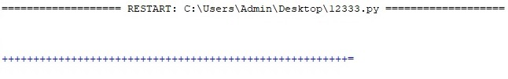

PRACTICAL -5

*REGULAR EXPRESSIONS*

**#Use of regular expression**

print("\n\n\n\n use of ^ character \n")

import re

string="hola! this is the word hello we say in espanol or spanish"

#use of ^ character

foundstart=re.findall("^holu", string)

if foundstart:

print("YES! the given string starts with the word hola")

else:

print("NO the string dont start with the word hola")

**#Use of $ character**

print("\n\n\n\n use of dollar sign \n")

string="hola! this is the word hello we say in espanol or spanish"

foundend=re.findall("spanish$", string)

if foundend:

print("yes the given string end with the word spanish")

else:

print("no the given string does not end with the word spanish")

**#Use of dot character**

print("\n\n\n\n use of dot character \n")

string="hola! this is the word hello we say in espanol or spanish"

x=re.findall("st...s", string)

print(x)

x=re.findall("e.....l", string)

print(x)

**#Use of star character**

print("\n\n\n\n use of star character \n")

string="hola! this is the word hello we say in espanol or spanish"

usestar=re.findall("inx*", string)

print(usestar)

usestar=re.findall("in*", string)

print(usestar)

**#Use of plus character**

print("\n\n\n\n use of plus character \n")

string="hola! this is the word hello we say in espanol or spanish"

useplus=re.findall("in+", string)

print(useplus)

useplus=re.findall("o+", string)

print(useplus)

**#Use of Compile Function**

import re

print("\n\n\n\n use of compile function \n")

#complie creates regular expression character class(a-e)

#which is eqivalent to [abcde]

pattern=re.compile('[a-e]')

print(pattern.findall("learning regular expressions"))

pattern=re.compile('[a-g]')

print(pattern.findall("learning regular expressions"))

pattern=re.compile('[A-Z]')

print(pattern.findall("Learning Regular Expressions"))

import re

print("\n\n\n\n use of capital d \n")

#\d is equivalent to [0-9].

usebackslashd=re.compile('\d')

print(usebackslashd.findall("Today is the day i go to the campsite with my family the date is 14th February 2021”))

print("\n\n\n\n use of capital d+ \n")

**#Use of \d+**

usebackslashd=re.compile('\d+')

print(usebackslashd.findall("Today is the day i go to the campsite with my family the date is 14th February 2021”))

print("\n\n\n\n use of capital w \n")

**#Use of \w**

usebackslashw=re.compile('\w')

print(usebackslashw.findall("Today is the day i go to the campsite with my family the date is 14th February 2021”))

print("\n\n\n\n use of capital(W) \n")

**#Use of \w+**

usebackslashw=re.compile('\W')

print(usebackslashw.findall("Today is the day i go to the campsite with my family the date is 14th February 2021"))

print("\n\n\n\n use of split funtion\n")

import re

#useof split function

gstring="Today is the day i go to the campsite with my family the date is 14th February 2021"

x=re.split("\s", gstring)

print(x)

print("\n\n\n\n use of sub method\n")

**#Use of sub method**

gstring="Today is the day i go to the campsite with my family the date is 14th February 2021"

x=re.sub("\s",",", gstring)

print(x)

**#Use of group method**

print("\n\n\n\n use of group \n")

string=re.match(r"(\w+) (\w+) (\w+)","Computer Science Python")

print(string.group(0))

print(string.group(1))

print(string.group(2))

print(string.group(3))

print(string.group(1,2,3))

def substitutor():

#a string variable

string_var="it's all about practice and learning"

print(re.sub(r"practice", "experience", string_var))

print("\n\n\n\n\n")

**#Using mobile number**

mobile_no_list=["9867260530","854796355","12344455566","7208521460"]

for val in mobile_no_list:

if re.match("[8-9] [1] [0-9] {9}",val):

print ("The mobile number",val,"is Correct")

else:

print("The mobile number",val," is not Correct")

**#Using Mail Id**

import re

#any character a-z, sny digit 0-9 and symbol '_' followed by a '@' symbol

#insert your text here

text= """This is an interesting scenario wherein you come across mail ids engrossed in the textual information

mail ids engrossed in the textual imformation

and you have to segregate these ids. Hello i Am Kaysan and my email id is sha.i.kh-kaysan@gmail.com this is

to extract mail id from text and this is learnt by kazim720@gmail.com

and also by kaheesha@yahoo.in"""

text1=text.lower()

print(re.findall(r"[\w.-]+@[\w.-]+", text1))

**OUTPUT:**

**Use of ^ character**

NO the string dont start with the word hola

**Use of dollar sign**

yes the given string end with the word spanish

**Use of dot character**

[]

['espanol']

**Use of star character**

['in']

['i', 'i', 'in', 'i']

**Use of plus character**

['in']

['o', 'o', 'o', 'o', 'o']

**Use of compile function**

['e', 'a', 'e', 'a', 'e', 'e']

['e', 'a', 'g', 'e', 'g', 'a', 'e', 'e']

['L', 'R', 'E']

**Use of capital d**

['1', '5', '2', '0', '2', '1']

**Use of capital d+**

['15', '2021']

**Use of capital w**

[‘T’,’o’,’d’,’a’,’y’,’i’,‘s’,’t’,’h’,’e’,’d’,’a’,’y’,‘I’,’g’,’o’,’t’,’o’,’t’,’h’,’e’,’c’,’a’,’m’,’p’,’s’,’I’,’t’,’e’,’w’,’i’,’t’,’h’,’m’,’y’,’f’,’a’,’m’,’i’,’l’,’y’,’t’,’h’,’e’,’d’,’a’,’t’,’e’,’i’,’s’,’1’,’4’,’t’,’h’,’F’,’e’,’b’,’r’,’u’,’a’,’r’,’y’,’2’,’0’,’2’,’1’ ]

**Use of capital(W)**

[' ', ' ', ' ', ' ', ' ', ' ', ' ', ' ', ' ', ' ', ' ', ' ', ' ', ' ', ' ', ' ', ' ', ' ']

**Use of split function**

[‘Today’ ‘is’ ‘the’ ‘day’ ‘i‘ ‘go’ ‘to’ ‘the’ ‘campsite’ ‘with’ ‘my’ ‘family’ ‘the’ ‘date’ ‘is’ ’14th’ ‘February’ ‘2021’]

**Use of sub method**

Today, is, the, day, i, go, to, the, campsite, with, my, family, the, date, is, 14th, February, 2021

**Use of group**

Computer Science Python

Computer

Science

Python

('Computer', 'Science', 'Python')

**Using mobile number**

The mobile number 9867260530 is not Correct

The mobile number 854796355 is not Correct

The mobile number 12344455566 is not Correct

The mobile number 7208521460 is not Correct

**Using Mail Id**

['sha.i.kh-kaysan@gmail.com', 'kazim720@gmail.com', 'kaheesha@yahoo.in']

date="2021-02-23 06:08:18"

PRACTICAL -6

**GUI (Using Tkinter Library)**

**#GUI in python (pack method and button widgets)**

**Input:**

import tkinter

from tkinter import *

window = Tk()

window.title("GUI Application in Python Environment")

Kaysan = Label(window, text = "Hello how are you all")

#Kaysan.pack()

Kaysan.pack(side = LEFT, expand = True, padx = 100, pady = 100)

window.mainloop()

**Output:**

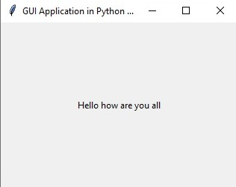

**Input:**

import tkinter

from tkinter import *

window=Tk()

def display():

print("Hi this is Button Widget")

button1=Button(window,text="Click to see the mesaage",command=display,bg='red',fg='green',font='arielblack',

height=10,width=20,bd=10)

button1.pack()

window.mainloop()

**Output:**

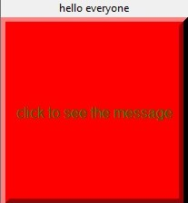

**Input:**

import tkinter.messagebox

def callback():

tkinter.messagebox.showinfo("Message box would appear as title"," Hi How are you all?")

callback()

def flatc():

print("Hello!Enjoying learning GUI feature")

flatc()

**Output:**

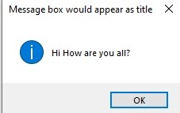

Hello!Enjoying learning GUI feature

**Input:**

from tkinter import *

import tkinter

relief_attrib = tkinter.Tk()

relief_flat=tkinter.Button(relief_attrib, text = "FLAT",

relief = FLAT, bg = 'green', fg = 'red', font='arielblack',

command = 'flatc')

relief_raised =tkinter.Button(relief_attrib, text="RAISED", state = NORMAL,

relief = RAISED, bg = 'orange', fg = 'yellow',

cursor = 'pencil')

relief_sunken = tkinter.Button(relief_attrib, text= "SUNKEN", relief = SUNKEN,

command = 'callback', cursor = 'tcross',

font = ('times','28','italic'), bg = 'red', fg= 'blue')

relief_groove = tkinter.Button(relief_attrib, text = "GROOVE", relief = GROOVE,

cursor = 'hand2', bg = 'yellow', fg = 'brown')

relief_ridge = tkinter.Button(relief_attrib, text = "RIDGE", relief = RIDGE,

cursor = 'heart', bg = 'red', fg = 'green')

quitb = tkinter.Button(relief_attrib, text = "QUIT", command = 'relief_attrib.destory')

quitb.pack(side = BOTTOM)

relief_flat.pack(side = LEFT, expand = True, padx = 10, pady = 30)

relief_raised.pack(side = RIGHT, expand = True, padx = 10, pady = 30)

relief_sunken.pack(side = TOP, expand = True, padx = 10, pady = 30)

relief_groove.pack(side = BOTTOM, expand = True, padx = 10, pady = 30)

relief_ridge.pack(side = LEFT, expand = True, padx = 10, pady = 30)

relief_attrib.mainloop()

**Output:**

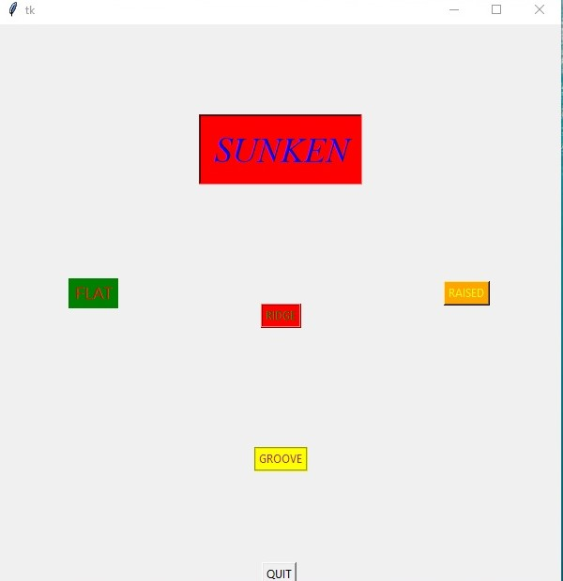

**Input:**

from tkinter import *

def opted():

selection="Selected category under Option No.: ---" + str(var.get())

label.config(text=selection)

mainwindow=Tk()

var=IntVar()

option1=Radiobutton(mainwindow,text="Sports:01",variable=var,value=1,command=opted)

option1.pack(anchor=N)

option2=Radiobutton(mainwindow,text="Entertainment:02",variable=var,value=2,command=opted)

option2.pack(anchor=E)

option3=Radiobutton(mainwindow,text="Travelling:03",variable=var,value=3,command=opted)

option3.pack(anchor=W)

option4=Radiobutton(mainwindow,text="Electronics:04",variable=var,value=4,command=opted)

option4.pack(anchor=S)

label=Label(mainwindow)

label.pack()

mainwindow.mainloop()

**Output:**

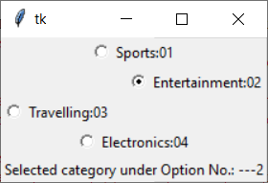

**Input:**

from tkinter import *

root_window = Tk()

root_window.geometry("400x400")

button_obj = Button(root_window, text = "Computer Science")

button_obj.pack()

**Output:**

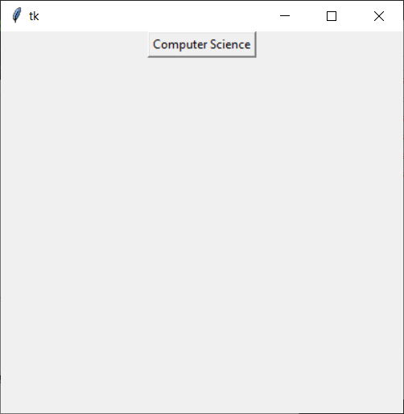

**Input:**

from tkinter import *

def frame_demo():

print("Learning importance of frame creation")

parent=Tk()

frame_obj1=Frame(parent)

frame_obj2=Frame(parent)

parent.title("Frame creation in today's class")

label_obj=Label(frame_obj1,text="FRAME",justify=LEFT)

label_obj.pack(side=LEFT)

button_obj=Button(frame_obj2,text="Function calling",command=frame_demo)

button_obj.pack()

frame_obj1.pack(padx=1,pady=1)

frame_obj2.pack(padx=10,pady=10)

parent.mainloop()

**Output:**

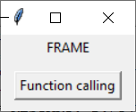

Learning importance of frame creation

**Input:**

from tkinter import *

root=Tk()

for i in range(2):

for j in range(2):

frame=Frame(root,relief=RAISED,borderwidth=2)

frame.grid(row=i,column=j)

label=Label(frame,text=f"Row {i}\nColumn {j}")

label.pack()

root.mainloop()

**Output:**

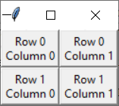

**Input:**

from tkinter import *

root=Tk()

btn_column=Button(root,text="This is column 2",bg="red")

btn_column.grid(column=2)

btn_columnspan=Button(root,text="With columnspan of 10",bg="blue")

btn_columnspan.grid(columnspan=10)

btn_ipadx=Button(root,text="padding horizontally ipadx of 5",bg="green")

btn_ipadx.grid(ipadx=5)

btn_ipady=Button(root,text="padding vertically ipady of 3",bg="yellow")

btn_ipady.grid(ipady=3)

btn_padx=Button(root,text="padx 4",bg="purple")

btn_padx.grid(padx=4)

btn_pady=Button(root,text="pady of 2",bg="violet")

btn_pady.grid(pady=2)

btn_row=Button(root,text="This is row 2")

btn_row.grid(row=2)

btn_rowspan=Button(root,text="With Rowspan of 3")

btn_rowspan.grid(rowspan=3)

btn_sticky=Button(root,text="Sticking to South-west")

btn_sticky.grid(sticky=SW)

root.mainloop

**Output:**

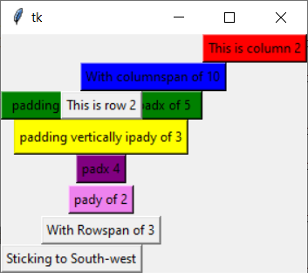

**Input:**

import tkinter as tk

color=["violet","indigo","blue","green","yellow","orange","red"]

rowno=0

for entities in color:

tk.Label(text=entities,relief=tk.RIDGE,width=25).grid(row=rowno,column=0)

tk.Entry(bg=entities,relief=tk.SUNKEN,width=10).grid(row=rowno,column=1)

rowno=rowno+1

tk.mainloop()

**Output:**

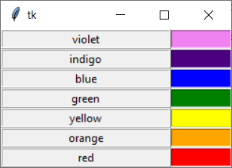

**Input:**

import tkinter as tk

activities=['Reading','Learning','Playing','Drawing','Writing']

r=['ACTIVITY']

for c in activities:

tk.Label(text=c,width=15).grid(column=0)

tk.Label(text=r,relief=tk.RIDGE,width=15).grid(column=1)

tk.mainloop()

**Output:**

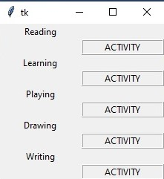

**Input:**

from tkinter import *

master=Tk()

#create a label widget

label_obj1=Label(master,text="Entry No. One")

label_obj2=Label(master,text="Entry No. Two:")

#Use of grid method

label_obj1.grid(row=0,column=0,sticky=W,pady=2)

label_obj2.grid(row=1,column=0,sticky=W,pady=2)

#Entry widgets, used to take entry from user

entry_obj1=Entry(master)

entry_obj2=Entry(master)

#This will arrange entry widgets

entry_obj1.grid(row=0,column=1,pady=2)

entry_obj2.grid(row=1,column=1,pady=2)

mainloop()

**Output:**

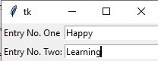

**Input:**

from tkinter import *

master=Tk()

listbox1=Listbox(master,selectmode=MULTIPLE)

listbox1.insert(1,"Travelling")

listbox1.insert(1,"Drawing")

listbox1.insert(2,"Cycling")

listbox1.insert(3,"Reading")

listbox1.pack()

master.mainloop()

**Output:**

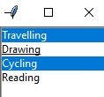

**Input:**

import tkinter as tk

root=tk.Tk()

T=tk.Text(root,height=10,width=50)

T.pack()

T.insert(tk.END,"""Very important feature in Python \n Illustrating Text box feature

\n Here we can display Multiple line of text \n But restricted by height and width

parameter specified""")

tk.mainloop()

**Output:**

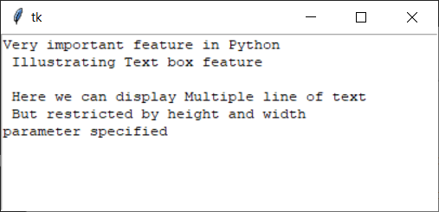

PRACTICAL -7

*HTML TAGS AND BROWSER*

**#HTML IN PYTHON**

import webbrowser

file_open=open("py.html","w")

content="""<html>

<head><title>How To Start Your Own Blogging</title></head><br><br>

<body bgcolor="pink">

<center>

<h1>BLOGGING</h1>

<p>Types of Blogging</p>

<ol type="a">

<li>Food Blogs</li>

<li>Fitness Blogs</li>

<li>DIY Blogs</li>

<li>Lifestyle Blogs</li>

</ol>

</hr>

<hr>

<p> Steps To Follow </p>

<ol>

<li>Choose your blog name and get your blog hosting.</li>

<li>Start your blog by adding WordPress.</li>

<li>Pick a simple theme to make your blog your own.</li>

<li>Add two key blogging plugins to find your readers and track stats.</li>

<li>Write compelling content to create a blog that your readers love</li>

</ol>

</hr>

<hr>

<p>HOW TO MAKE IMPROVEMENTS</p>

<ol type="1">

<li>Write catchier headlines. ...</li>

<li>Use scannable formatting. ...</li>

<li>Ask experts to guest post.</li>

</ul>

</hr>

<hr>

<p> WANT TO MAKE YOUR OWN BLOG ...</p>

FILL THE REQUIRED DETAILS AND SUMBIT IT!!!<br><br>

<form>

<label for="fname">First name:</label><br>

<input type="text" id="fname" name="fname"><br>

<label for="lname">Last name:</label><br>

<input type="text" id="lname" name="lname"><br>

Enter your Address<br>

<textarea row="2" cols="20"></textarea><br><br>

<b>Which Blogging Page You Want To Create ?</b><br><br>

<input type="checkbox",name="Food Blog">Food Blog<br><br>

<input type="checkbox",name="Fitness Blog">Fitness Blog<br><br>

<input type="checkbox",name="DIY Blog">DIY Blog<br><br>

<input type="checkbox",name="Lifestyle Blog Blog">DIY Blog<br><br>

<input type="Submit"><br><br>

</form>

</hr>

</body>

</html>"""

file_open.write(content)

file_open.close()

webbrowser.open_new_tab('py.html')

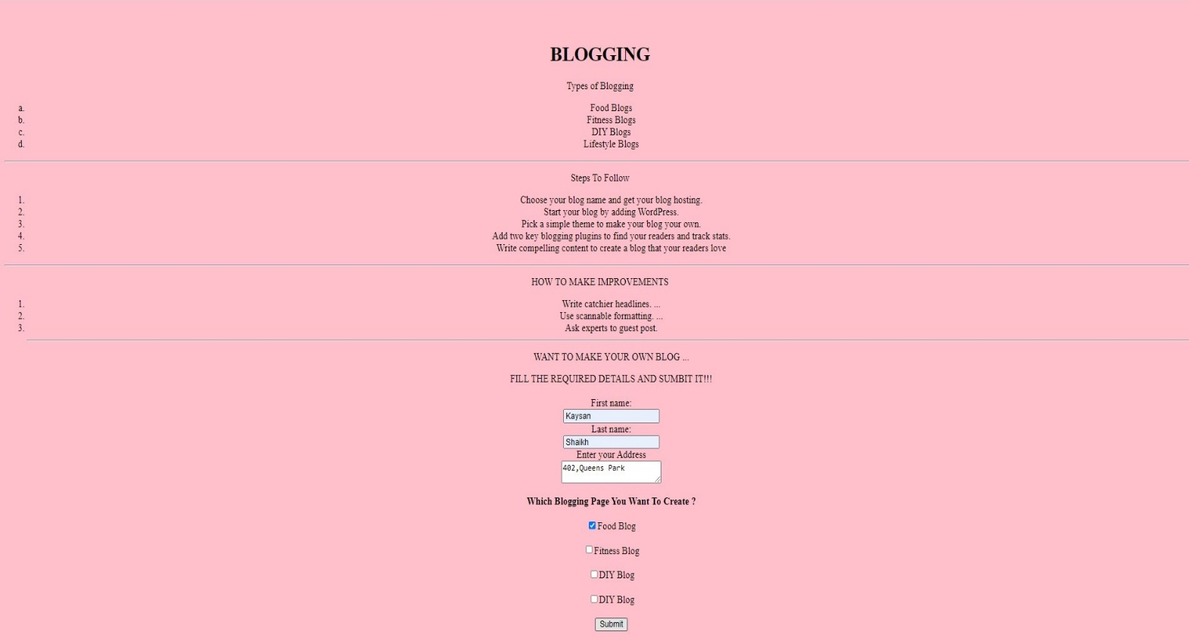**Output:**

ASSIGNMENT-2

APPLICATION FORM (GUI) IN PYTHON

***USING TKINTER LIBRARY***

from tkinter import *

form = Tk()

form.geometry("600x600")

form.title("Application Form")

label=Label(form,text="Fill the form details carefully.")

label.pack()

Firstname=Label(form,text="First Name",).pack()

n1=Entry(form).pack()

Middlename=Label(form,text="Middle Name").pack()

n2=Entry(form).pack()

Lastname=Label(form,text="Last Name").pack()

n3=Entry(form).pack()

DOB=Label(form,text="Date of Birth").pack()

n4=Entry(form).pack()

MobileNo=Label(form,text="Mobile No").pack()

n5=Entry(form).pack()

EmailId=Label(form,text="Email Id").pack()

n6=Entry(form).pack()

var=IntVar()

stream=Label(form,text="Which Stream you want to choose ?").pack()

opt1=Radiobutton(form,text="Physics",variable=var)

opt1.pack(anchor=W)

var=IntVar()

opt2=Radiobutton(form,text="Chemistry",variable=var)

opt2.pack(anchor=W)

var=IntVar()

opt3=Radiobutton(form,text="Zoology",variable=var)

opt3.pack(anchor=W)

var=IntVar()

opt4=Radiobutton(form,text="Computer Science",variable=var)

opt4.pack(anchor=W)

def click():

print("Your response has been recorded. THANK YOU")

button=Button(form,text="Submit",command=click)

button.pack()

form.mainloop()

**Output:**

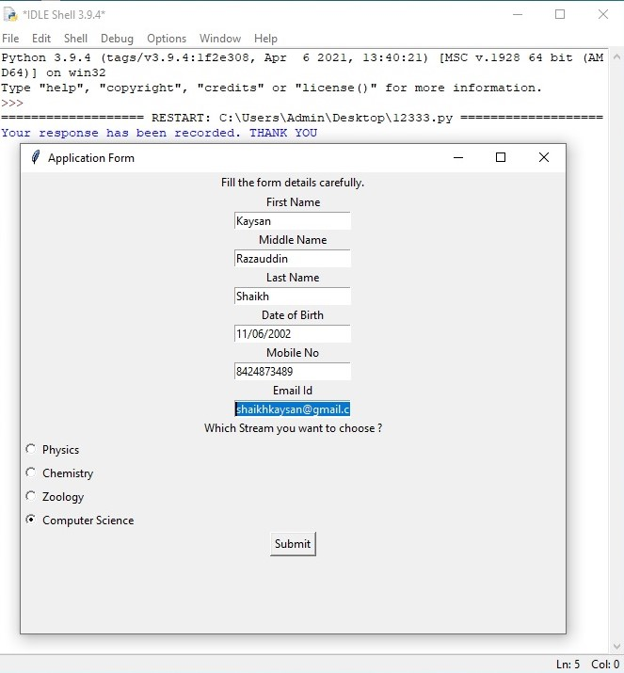

PRACTICAL -8

*CANVAS*

**#canvas in python**

**#creating line in canvas**

from tkinter import *

class CSline():

def __init__(self):

self.main_window=Tk()

self.canvas=Canvas(self.main_window,width=800,height=800)

self.canvas.create_line(0,0,799,799)

self.canvas.create_line(799,0,0,799)

self.canvas.pack()

mainloop()

abline=CSline()

**Output:**

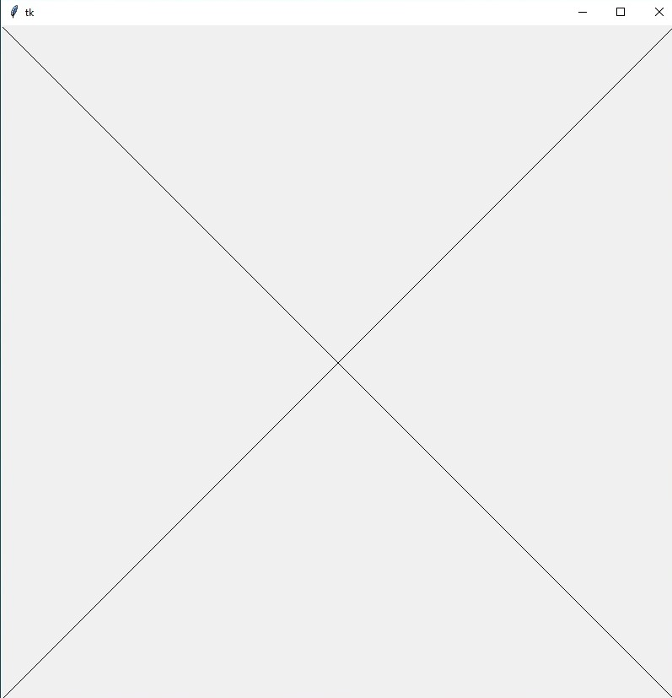

**#creating rectangle**

from tkinter import *

class rectangle():

def __init__(self):

self.main_window=Tk()

self.canvas=Canvas(self.main_window,height=900,width=800)

self.canvas.create_rectangle(100,100,200,200)

self.canvas.pack()

mainloop()

abrectangle=rectangle()

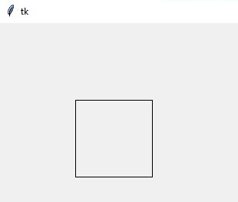**Output:**

**#creating oval**

from tkinter import *

class oval():

def __init__(self):

self.main_window=Tk()

self.canvas=Canvas(self.main_window,height=900,width=800)

self.canvas.create_oval(100,200,100,200)

self.canvas.pack()

mainloop()

aboval=oval()

**Output:**

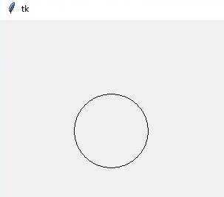

**#creating text**

from tkinter import *

class text():

def __init__(self):

self.main_window=Tk()

self.canvas=Canvas(self.main_window,height=900,width=800)

self.canvas.create_text(450,400,text="You are enter in Canvas Window")

self.canvas.pack()

mainloop()

abtext=text()

**Output:**

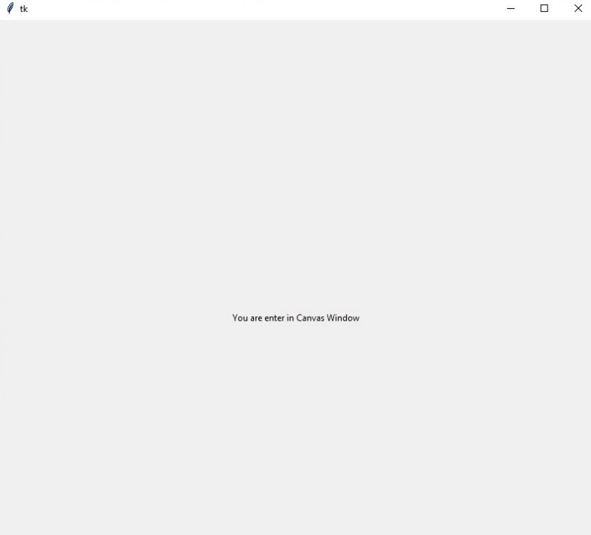

**#creating canvas without using the init method**

from tkinter import *

main=Tk()

can_obj = Canvas(main,bg="green",height=900,width=900)

**#line = can_obj.create_line(0,899,899,0,fill='yellow')**

arc = can_obj.create_arc(250,300,400,500,start=0,extent=180,fill="black")

arc = can_obj.create_arc(300,400,500,600,start=0,extent=180,fill="black")

arc = can_obj.create_arc(350,400,500,600,start=0,extent=-180,fill="red")

oval = can_obj.create_oval(200,250,650,700)

can_obj.pack()

mainloop()

**Output:**

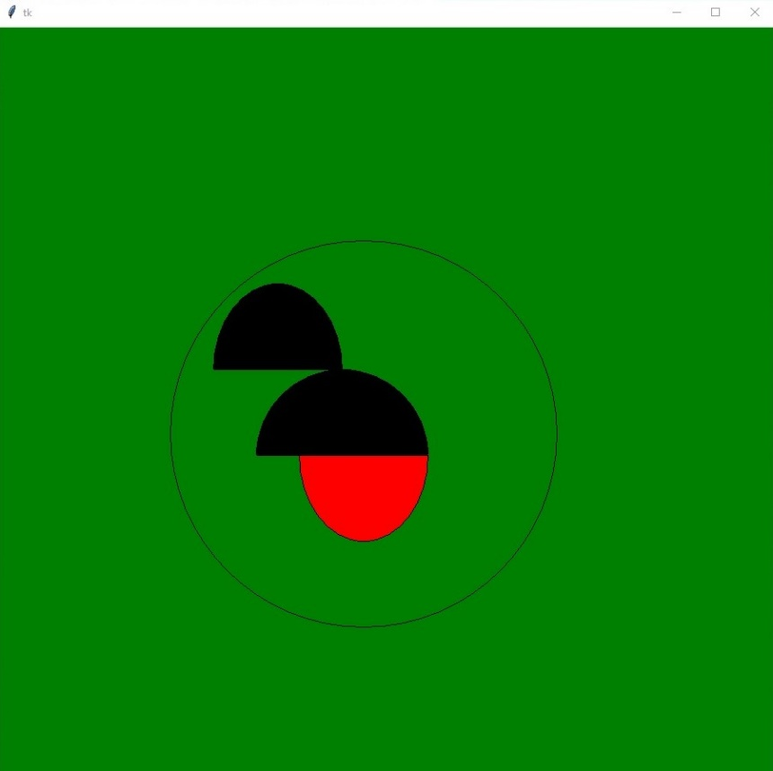

from tkinter import *

canvas_width=500

canvas_height=150

def paint(event):

python_green="#476042"

x1,y1=(event.x-1),(event.y-1)

x2,y2=(event.x-1),(event.y-1)

can_obj.create_oval(x1,y1,x2,y2,fill=python_green)

def clearall():

can_obj.delete("all")

master=Tk()

master.title("Text display using Ovals")

can_obj=Canvas(master,width=canvas_width,height=canvas_height)

can_obj.pack(expand=YES,fill=BOTH)

can_obj.bind("<B1-Motion>",paint)

message=Label(master,text="Press and Drag the mouse to draw")

message.pack(side=BOTTOM)

button=Button(master,text="Clear",command=clearall)

button.pack(side=BOTTOM)

mainloop()

**Output:**

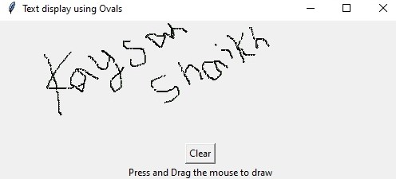

**#Example of bind method**

from tkinter import *

root=Tk()

root.geometry('200x100')

**#function to be called when mouse enters in a frame**

def enter(event):

print("Coordinates [Entering frame] at x=%d,y=%d"%(event.x,event.y))

#function to be called when mouse exits the frame

def exit(event):

print("Coordinates [Exiting frame] at x=%d,y=%d"%(event.x,event.y))

frameobject=Frame(root,height=100,width=200)

frameobject.bind('<Enter>',enter)

frameobject.bind('<Leave>',exit)

frameobject.pack()

quitb=tkinter.Button(frameobject,text="QUIT",command=relief_attrib.destroy)

quitb.pack(side=BUTTON)

mainloop()

**Output:**

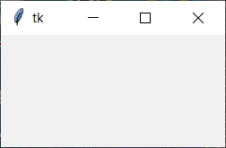

Coordinates [Entering frame] at x=166,y=95

Coordinates [Exiting frame] at x=230,y=39

Coordinates [Entering frame] at x=33,y=94

Coordinates [Exiting frame] at x=28,y=144

**#finding the key pressed in keyboard**

from tkinter import *

#finding key pressed in keyboard

def presskey(label):

value=label.char

print(value,'button is pressed')

mainwindow=Tk()

mainwindow.geometry('300x150')

mainwindow.bind('<Key>',lambda i:presskey(i))

mainloop()

**Output:**

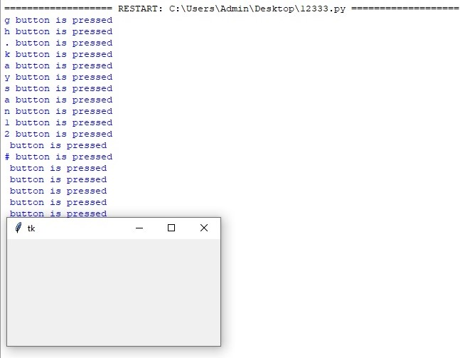

ASSIGNMENT-3

Create a Simple Calculator using Tkinter

# Python program to create a simple GUI

# calculator using Tkinter

from tkinter import *

# globally declare the expression variable

expression = ""

def press(num):

global expression

expression = expression + str(num)

equation.set(expression)

# Function to evaluate the final expression

def equalpress():

try:

global expression

total = str(eval(expression))

equation.set(total)

expression = ""

except:

equation.set(" error ")

expression = ""

# Function to clear the contents

# of text entry box

def clear():

global expression

expression = ""

equation.set("")

# Driver code

if __name__ == "__main__":

# create a GUI window

gui = Tk()

gui.configure(background="light green")

gui.title("Simple Calculator")

gui.geometry("270x150")

equation = StringVar()

expression_field = Entry(gui, textvariable=equation)

expression_field.grid(columnspan=4, ipadx=70)

button1 = Button(gui, text=' 1 ', fg='black', bg='red',

command=lambda: press(1), height=1, width=7)

button1.grid(row=2, column=0)

button2 = Button(gui, text=' 2 ', fg='black', bg='red',

command=lambda: press(2), height=1, width=7)

button2.grid(row=2, column=1)

button3 = Button(gui, text=' 3 ', fg='black', bg='red',

command=lambda: press(3), height=1, width=7)

button3.grid(row=2, column=2)

button4 = Button(gui, text=' 4 ', fg='black', bg='red',

command=lambda: press(4), height=1, width=7)

button4.grid(row=3, column=0)

button5 = Button(gui, text=' 5 ', fg='black', bg='red',

command=lambda: press(5), height=1, width=7)

button5.grid(row=3, column=1)

button6 = Button(gui, text=' 6 ', fg='black', bg='red',

command=lambda: press(6), height=1, width=7)

button6.grid(row=3, column=2)

button7 = Button(gui, text=' 7 ', fg='black', bg='red',

command=lambda: press(7), height=1, width=7)

button7.grid(row=4, column=0)

button8 = Button(gui, text=' 8 ', fg='black', bg='red',

command=lambda: press(8), height=1, width=7)

button8.grid(row=4, column=1)

button9 = Button(gui, text=' 9 ', fg='black', bg='red',

command=lambda: press(9), height=1, width=7)

button9.grid(row=4, column=2)

button0 = Button(gui, text=' 0 ', fg='black', bg='red',

command=lambda: press(0), height=1, width=7)

button0.grid(row=5, column=0)

plus = Button(gui, text=' + ', fg='black', bg='red',

command=lambda: press("+"), height=1, width=7)

plus.grid(row=2, column=3)

minus = Button(gui, text=' - ', fg='black', bg='red',

command=lambda: press("-"), height=1, width=7)

minus.grid(row=3, column=3)

multiply = Button(gui, text=' * ', fg='black', bg='red',

command=lambda: press("*"), height=1, width=7)

multiply.grid(row=4, column=3)

divide = Button(gui, text=' / ', fg='black', bg='red',

command=lambda: press("/"), height=1, width=7)

divide.grid(row=5, column=3)

equal = Button(gui, text=' = ', fg='black', bg='red',

command=equalpress, height=1, width=7)

equal.grid(row=5, column=2)

clear = Button(gui, text='Clear', fg='black', bg='red',

command=clear, height=1, width=7)

clear.grid(row=5, column='1')

Decimal= Button(gui, text='.', fg='black', bg='red',

command=lambda: press('.'), height=1, width=7)

Decimal.grid(row=6, column=0)

gui.mainloop()

Output:

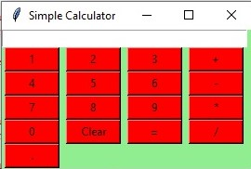

PRACTICAL -9

*DATABASE CONNECTION*

import sqlite3

#connecting to the database

#If the databse does not exist, then it will be created

#and then a database object will be returned.

conn_db =sqlite3.connect('cs.db')

print ("Opened database successfully")

cursor_object = conn_db.cursor()

print("Cursor object created successfully")

#conn_db.execute('drop table computer')

conn_db.execute(''' CREATE TABLE computer

(ROLLNO INT PRIMARY KEY NOT NULL,

NAME TEXT NOT NULL,

SUBJECT1 INT NOT NULL,

SUBJECT2 INT NOT NULL,

GRADE CHAR(5),

SGPI REAL);''')

print("Table created")

conn_db.execute("INSERT INTO computer (ROLLNO,NAME,SUBJECT1,SUBJECT2,GRADE,SGPI ) \

VALUES(1001,'LOKESH',85,99,'A',9.20)");

conn_db.execute("INSERT INTO computer (ROLLNO,NAME,SUBJECT1,SUBJECT2,GRADE,SGPI ) \

VALUES(1002,'RAMESH',75,69,'B',8.00)");

conn_db.execute("INSERT INTO computer (ROLLNO,NAME,SUBJECT1,SUBJECT2,GRADE,SGPI ) \

VALUES(1003,'SURESH',95,99,'0',10.0)");

print("Records inserted into the database")

cursor_obj=conn_db.execute("Select ROLLNO,NAME,SUBJECT1,SUBJECT2,GRADE,SGPI from computer")

for row in cursor_obj:

print("ROLL NO = " ,row[0])

print("NAME = ",row[1])

print("SUBJECT1 =" ,row[2])

print("SUBJECT2 = ",row[3])

print("GRADE = ",row[4])

print("SGPI=",row[5],"\n")

#print(cursor_obj.fetchall())

conn_db.commit()

conn_db.close()

**OUTPUT:**

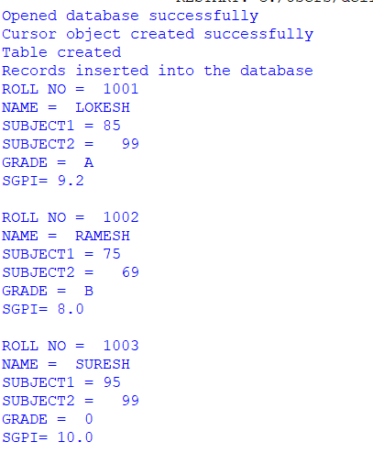

ASSIGNMENT-4

TRAVERSE IN PYTHON

import tkinter as tk

def show_frame(frame):

frame.tkraise()

window=tk.Tk()

window.state('zoomed')

window.rowconfigure(0,weight=1)

window.columnconfigure(0,weight=1)

frame1=tk.Frame(window)

frame2=tk.Frame(window)

frame3=tk.Frame(window)

for frame in (frame1,frame2,frame3):

frame.grid(row=0,column=0,sticky='nsew')

#=============frame1 code======================

frame1_title=tk.Label(frame1,text="Page 1",bg="red")

frame1_title.pack(fill='x')

frame1_btn=tk.Button(frame1,text="Next",command=lambda:show_frame(frame2))

frame1_btn.pack()

frame2_title=tk.Label(frame2,text="Page 2",bg="yellow")

frame2_title.pack(fill='x')

frame2_btn=tk.Button(frame2,text="Next",command=lambda:show_frame(frame3))

frame2_btn.pack()

frame3_title=tk.Label(frame3,text="Page 3",bg="green")

frame3_title.pack(fill='x')

frame3_btn=tk.Button(frame3,text="Next",command=lambda:show_frame(frame1))

frame3_btn.pack()

window.mainloop()

**Output:**

